SQL Select statement

Basic SELECT statement
- Write a query to display the names (first_name, last_name) using alias name “First Name", "Last Name" from employees table.

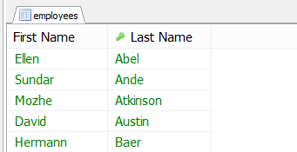
- .
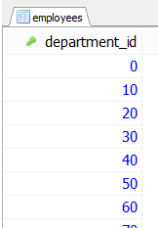
- Write a query to get all employee details from the employees table order by first name, descending.
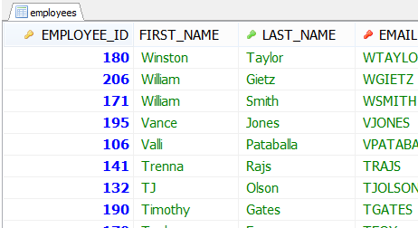

- Write a query to get the names (first_name, last_name), salary, PF of all the employees (PF is calculated as 15% of salary).

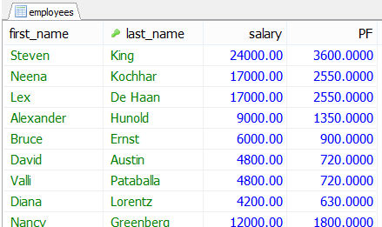

- Write a query to get the number of jobs available in the employees table.
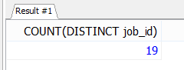
- Write a query get all first name from employees table in upper case.
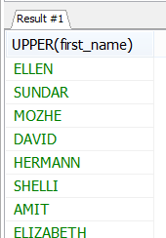

- Write a query to get the first 3 characters of first name from employees table.

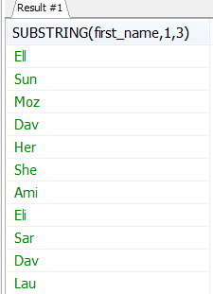
- Write a query to get the names (for example Ellen Abel, Sundar Ande etc.) of all the employees from employees table.

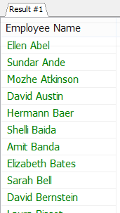

- Write a query to get first name from employees table after removing white spaces from both side.
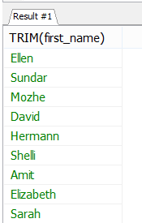

- Write a query to get the length of the employee names (first_name, last_name) from employees table.
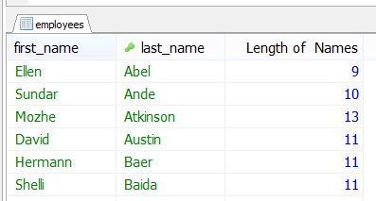

MySQL Restricting and Sorting Data

- Write a query to display the names (first_name, last_name) and salary for all employees whose salary is not in the range $10,000 through $15,000.
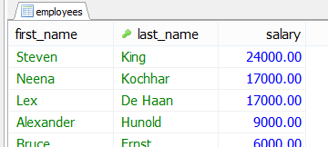

- Write a query to display the names (first_name, last_name) and department ID of all employees in departments 30 or 100 in ascending alphabetical order by department ID.

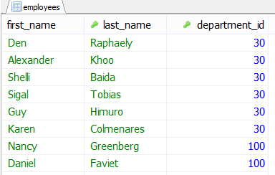

- Write a query to display the names (first_name, last_name) and salary for all employees whose salary is not in the range $10,000 through $15,000 and are in department 30 or 100.

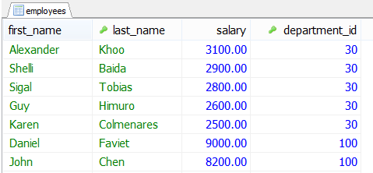

- Write a query to display the names (first_name, last_name) and hire date for all employees who were hired in 1990.
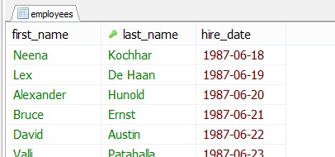

- Write a query to display the first_name of all employees who have both an "b" and "c" in their first name.
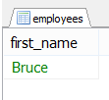
- Write a query to display the last name, job, and salary for all employees whose job is that of a Programmer or a Shipping Clerk, and whose salary is not equal to $4,500, $10,000, or $15,000.
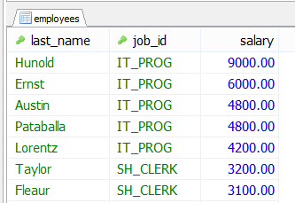

- Write a query to display the last names of employees whose names have exactly 6 characters.
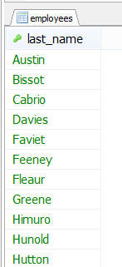

- Write a query to display the last names of employees having 'e' as the third character.
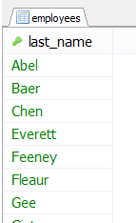

- Write a query to display the jobs/designations available in the employees table.
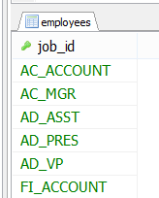

Aggregate Functions and Group by

- Write a query to list the number of jobs available in the employees table.
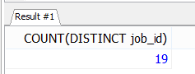
- Write a query to get the total salaries payable to employees.
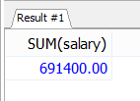
- Write a query to get the minimum salary from employees table.
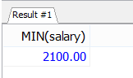

- Write a query to get the maximum salary of an employee working as a Programmer.
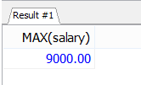
- Write a query to get the average salary and number of employees working the department 90.
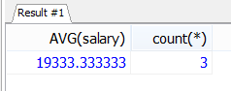
- Write a query to get the highest, lowest, sum, and average salary of all employees.
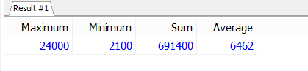

- Write a query to get the number of employees with the same job.
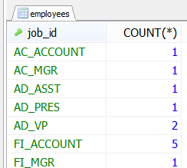
- Write a query to get the difference between the highest and lowest salaries.
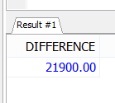
- Write a query to find the manager ID and the salary of the lowest-paid employee for that manager.
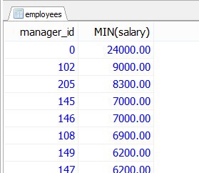
- Write a query to get the department ID and the total salary payable in each department.

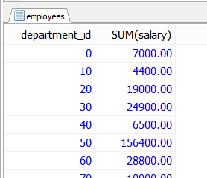

- Write a query to get the average salary for each job ID excluding programmer.
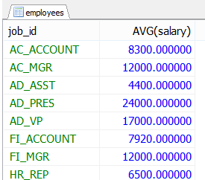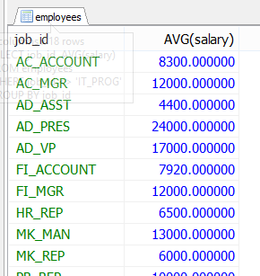

- Write a query to get the total salary, maximum, minimum, average salary of employees (job ID wise), for department ID 90 only.

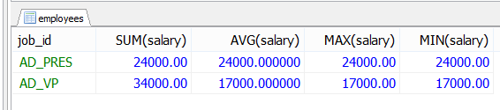

- Write a query to get the job ID and maximum salary of the employees where maximum salary is greater than or equal to $4000.
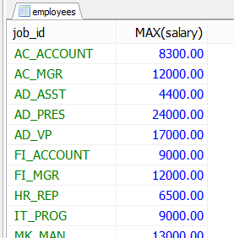

- Write a query to get the average salary for all departments employing more than 10 employees.

